Assignment 10:

Write a C program that defines a structure Rectangle with attributes length and width. Include a user-defined function named calculateArea with the signature float calculateArea(struct Rectangle r);. The function should calculate and return the area of the rectangle.

Source Code:

#include<stdio.h>
struct Rectangle {
float length,width;
};
float calculateArea(struct Rectangle r) {
return r.length * r.width;
}
int main() {
struct Rectangle r;
float area;
printf("Enter the Length of the Rectangle : ");
scanf("%f",&r.length);
printf("\nEnter the width of the Rectangle : ");
scanf("%f",&r.width);
area = calculateArea(r);
printf("The area of the Rectangle is %.2f",area);
return 0;
}

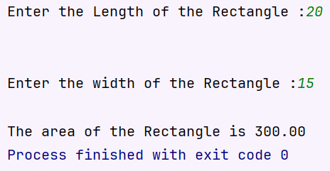
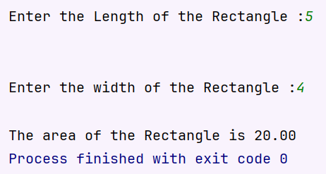
Output:

